**Bug Title:** When uploading images and writing long descriptions, the text doesn't follow the frame

**Bug ID:** Bug 001

**Area Path:** USERS menu -> Komunitas

**Build Number:** Version Number 5.0.1

**Severity:** LOW

**Priority:** HIGH

**Assigned to:** Elvanisa Muhsina

**Reported By:** Agam Aprianto

**Reported On:** 14 Juli 2022

**Reason:** Defect

**Status:** New/Open

**Device:** ASUS A456U 2017

**Browser:** Chrome 103

**Description: The application** when uploading images and writing long descriptions, the text doesn't follow the frame

**Steps to Reproduce:**

**1)** Login into the Application.

**2)** Navigate to the Dashboard -> New Comunity

**3)** Filled out all the user information fields.

**4)** Clicked on the ‘Simpan’ button.

**5)** Seen an bug page

**6)** Also see the attached screenshot of the error page.

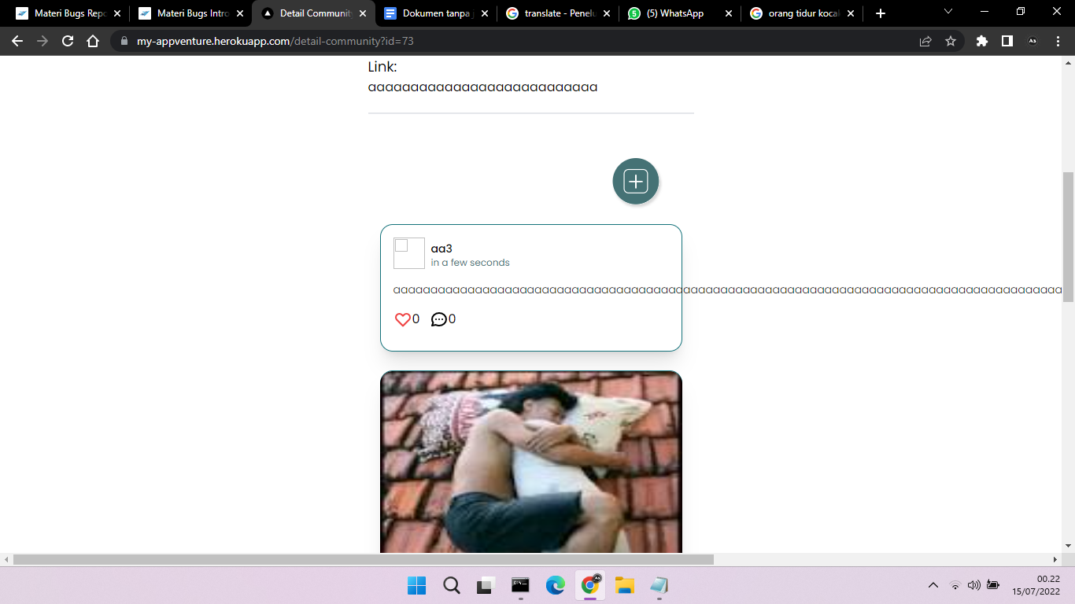

**Expected Result:** When clicking the SAVE button, the status of the community should be in the frame

**Bug Title:** Application can’t upload profile picture

**Bug ID:** Bug 002

**Area Path:** Profile menu -> Profile Saya

**Build Number:** Version Number 5.0.1

**Severity:** LOW

**Priority:** HIGH

**Assigned to:** Elvanisa Muhsina

**Reported By:** Agam Aprianto

**Reported On:** 14 Juli 2022

**Reason:** Defect

**Status:** New/Open

**Device:** ASUS A456U 2017

**Browser:** Chrome 103

**Description: The** Application can’t upload profile picture

**Steps to Reproduce:**

**1)** Login into the Application.

**2)** Navigate to the Profile Menu

**4)** Clicked on the ‘Profile Saya’ button.

**5)** Seen an bug page

**6)** Also see the attached screenshot of the error page.

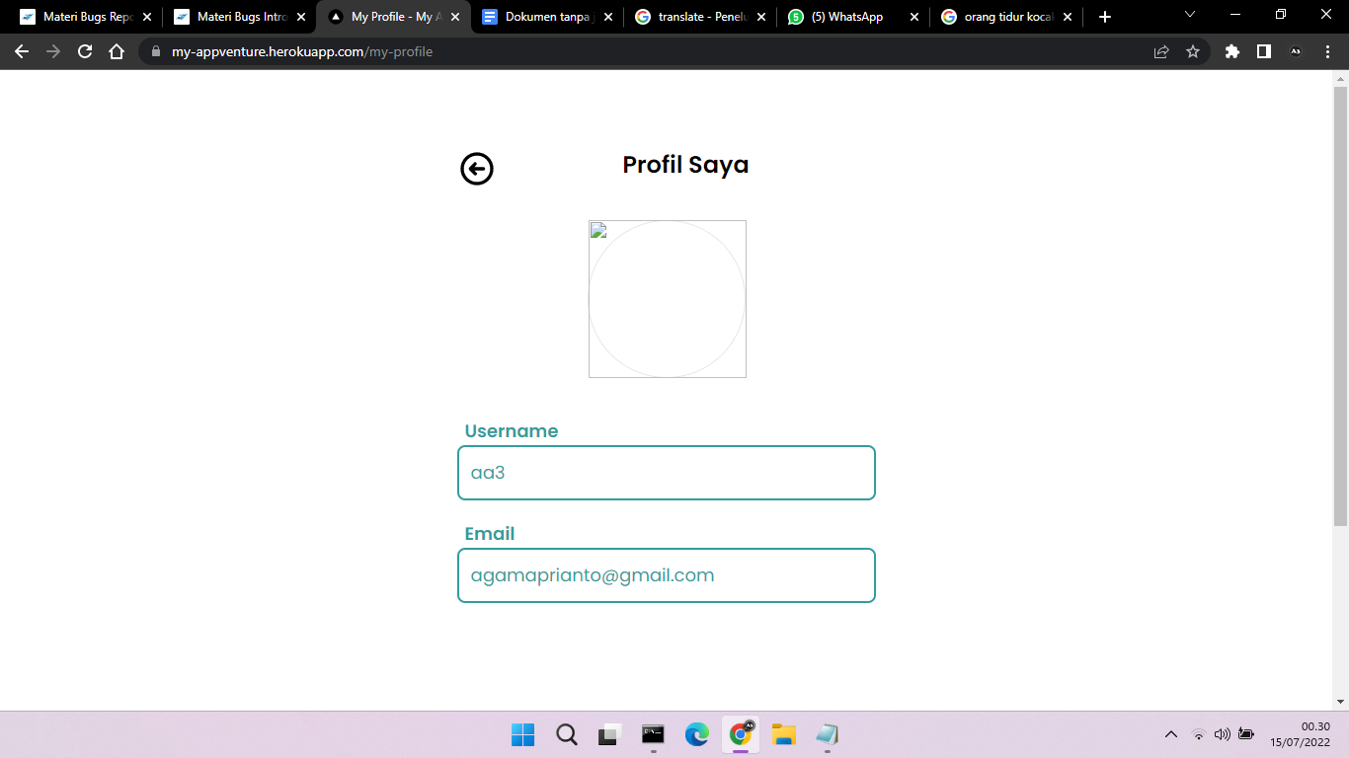

**Expected Result:** When clicking the profile menu button, you must be able to upload a profile photo

**Bug Title:** When input the community name correctly in the community textbox, the entered comunity name does not appear

**Bug ID:** Bug 003

**Area Path:** Dashboard menu -> Textbox comunity

**Build Number:** Version Number 5.0.1

**Severity:** MEDIUM

**Priority:** HIGH

**Assigned to:** Elvanisa Muhsina

**Reported By:** Agam Aprianto

**Reported On:** 14 Juli 2022

**Reason:** Defect

**Status:** New/Open

**Device:** ASUS A456U 2017

**Browser:** Chrome 103

**Description: The** Application can’t display what we input

**Steps to Reproduce:**

**1)** Login into the Application.

**2)** Navigate to the Dashboard Menu

**4)** Clicked on the Textbox menu.

**5)** Input correct comunity name

**6)** Also see the attached screenshot of the error page.

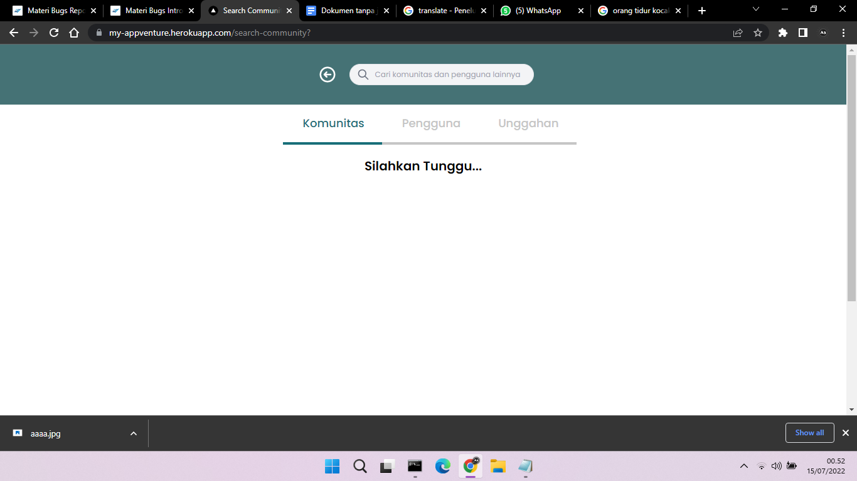

**Expected Result:** When input the correct comunity name, should be able to display the input community name

**Bug Title:** When replying to a comment on the second user on the first user post no notification appears

**Bug ID:** Bug 004

**Area Path:** Dashboard menu

**Build Number:** Version Number 5.0.1

**Severity:** MEDIUM

**Priority:** HIGH

**Assigned to:** Elvanisa Muhsina

**Reported By:** Agam Aprianto

**Reported On:** 20 Juli 2022

**Reason:** Defect

**Status:** New/Open

**Device:** ASUS A456U 2017

**Browser:** Chrome 103

**Description:** notifications do not appear when there is a response from a comment

**Steps to Reproduce:**

**1)** Login into the Application.

**2)** Navigate to the Dashboard Menu

**4)** Clicked on the icon comment menu

**5)** Input comment with second user

**6)** Also see the attached screenshot of the error page.

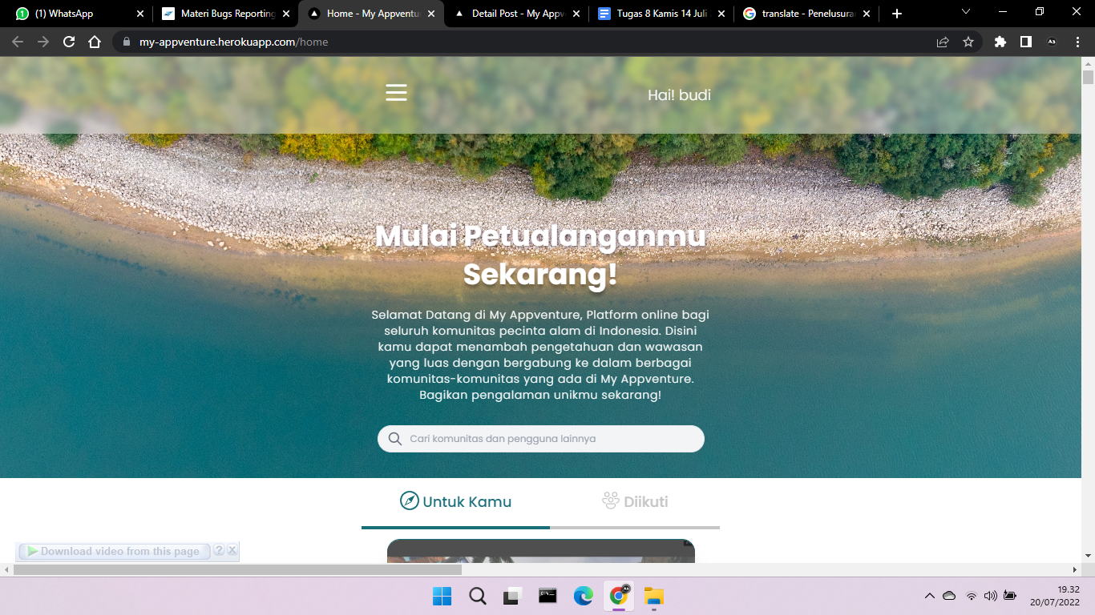

**Expected Result:** When comment on the second account, you should get a notification on the first account

**Bug Title:** When posting to the community group an error message appears

**Bug ID:** Bug 005

**Area Path:** Dashboard menu -> Textbox comunity

**Build Number:** Version Number 5.0.1

**Severity:** HIGH

**Priority:** HIGH

**Assigned to:** Elvanisa Muhsina

**Reported By:** Agam Aprianto

**Reported On:** 20 Juli 2022

**Reason:** Defect

**Status:** New/Open

**Device:** ASUS A456U 2017

**Browser:** Chrome 103

**Description:** error message when trying to post to a community group

**Steps to Reproduce:**

**1)** Login into the Application.

**2)** Navigate to the Dashboard Menu

**4)** Clicked on the Community Menu

**5)** Input text in community grup

**6)** Also see the attached screenshot of the error page.

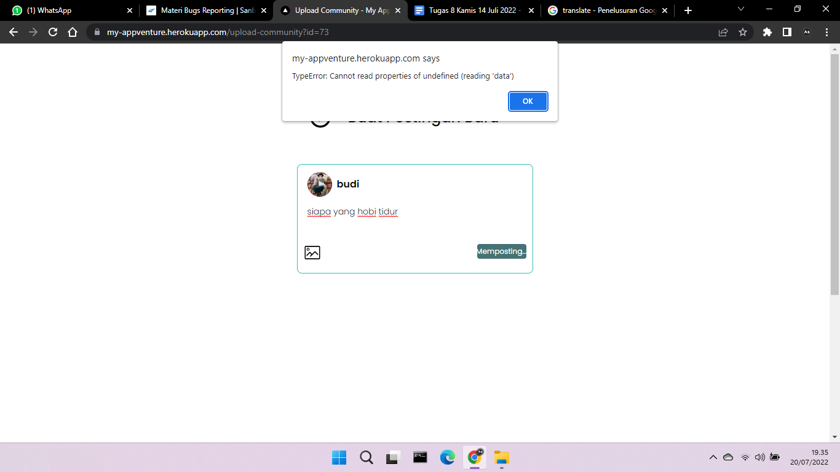

**Expected Result:** When posting in the community group should be able to enter the dashboard menu